**Log Journal Alert (Book Generator)**

1. Go to Book Generator section

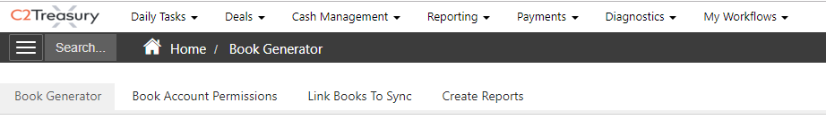

1. Create a new Book by filling Book Generator Editor
   1. Book Name (Unique Identifier of the book alert)
   2. Send Time (Time report is sent)
   3. Emails (set of predefined system or newly added emails)
   4. Format (Excel or PDF)
   5. Days: Frequency of receiving the report

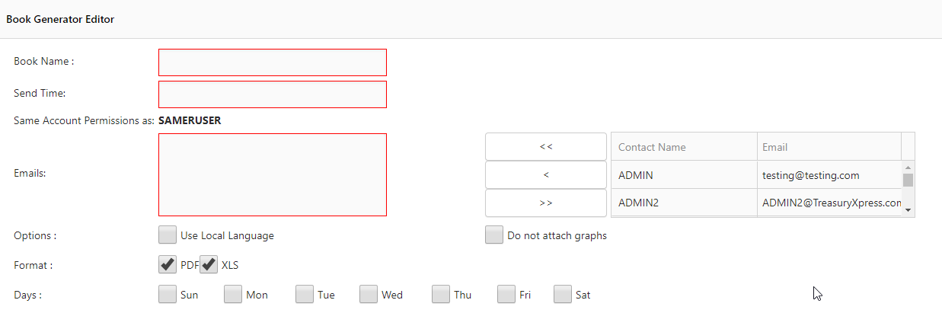

1. Book Report List
   1. Select Log Journal Alerts under Alert Report

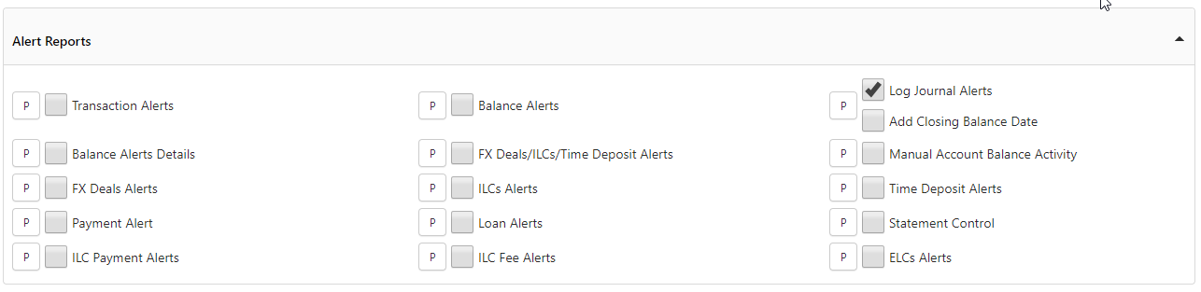

1. Book Account Permission
   1. Select the accounts that will be included in the report (single or multiple accounts)

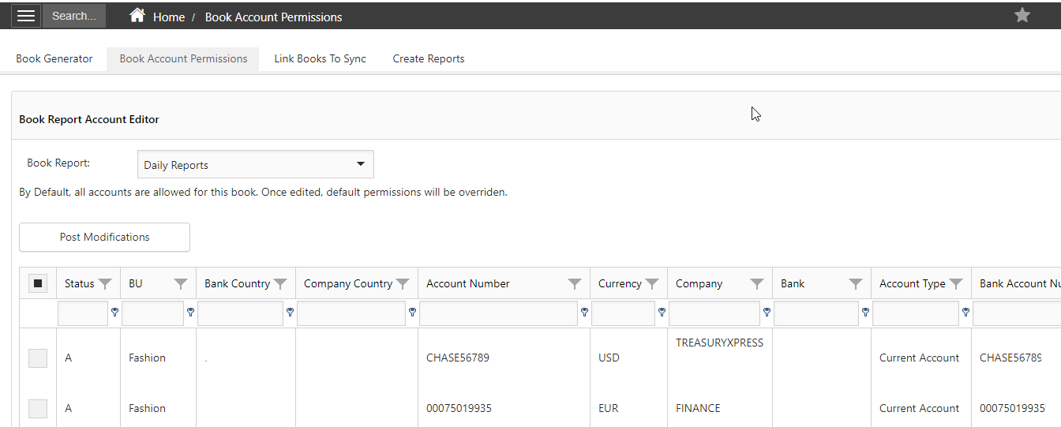

1. Receiving book details
   1. Report will be received by email based on the time and day defined in the book generator editor
   2. To generate the report for a specific date go to Book Generator and select to “Edit” , then launch with specific date or launch date (today’s date)

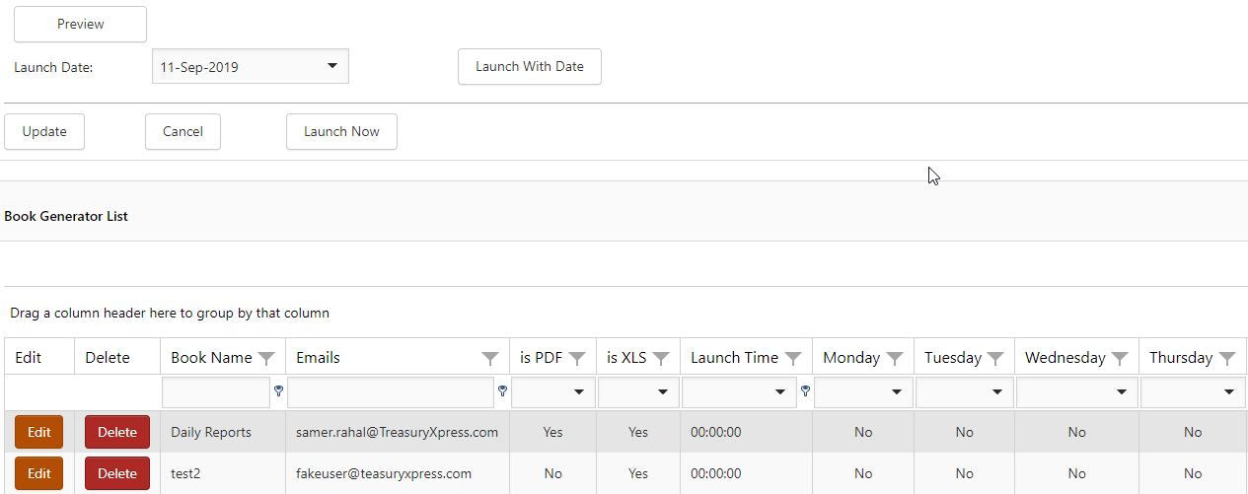

1. Report Details (sections)

